# Appendix II. Variable statistics description

# Appendix III. Test results

**Breusch and Pagan Lagrangian multiplier test**

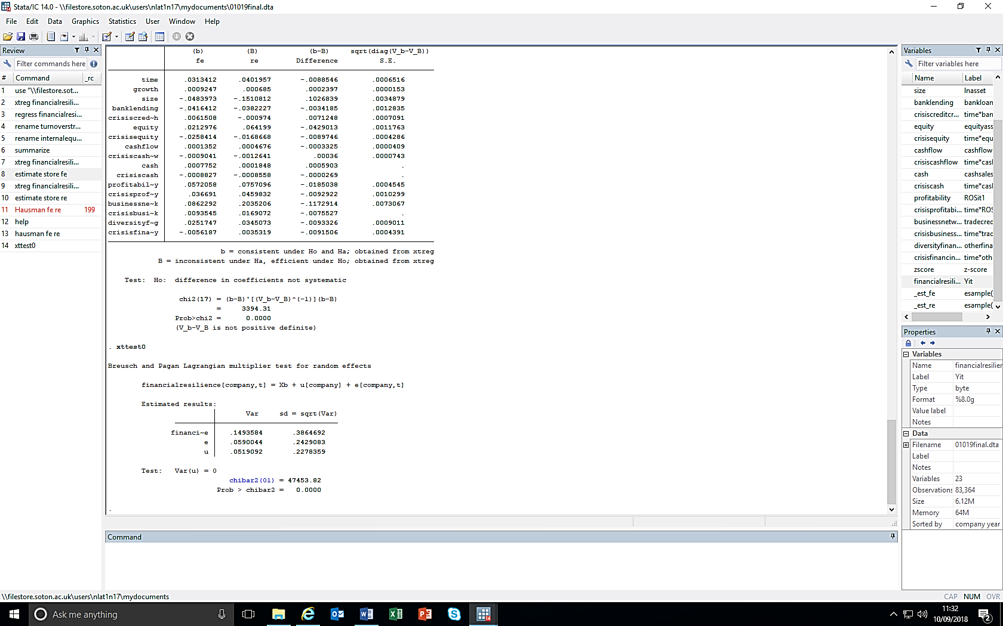

**Hausman test**

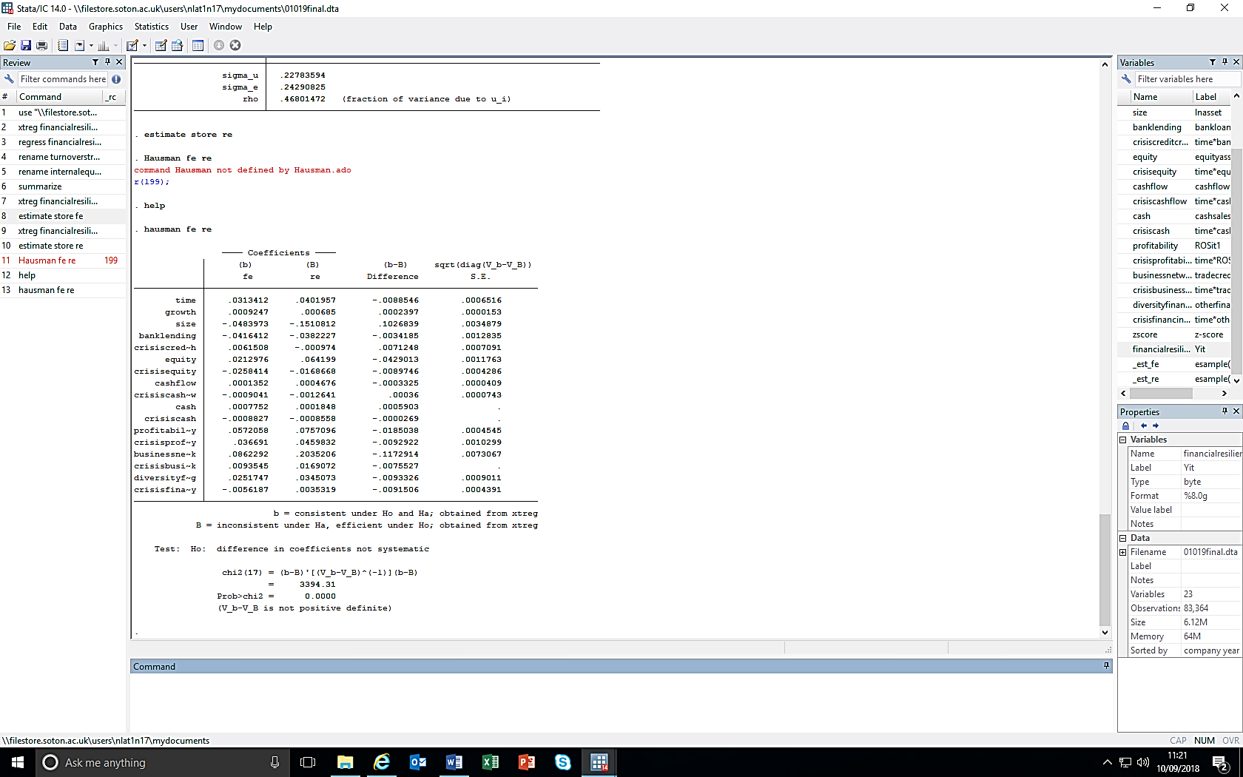

**Fixed Effects regression result**

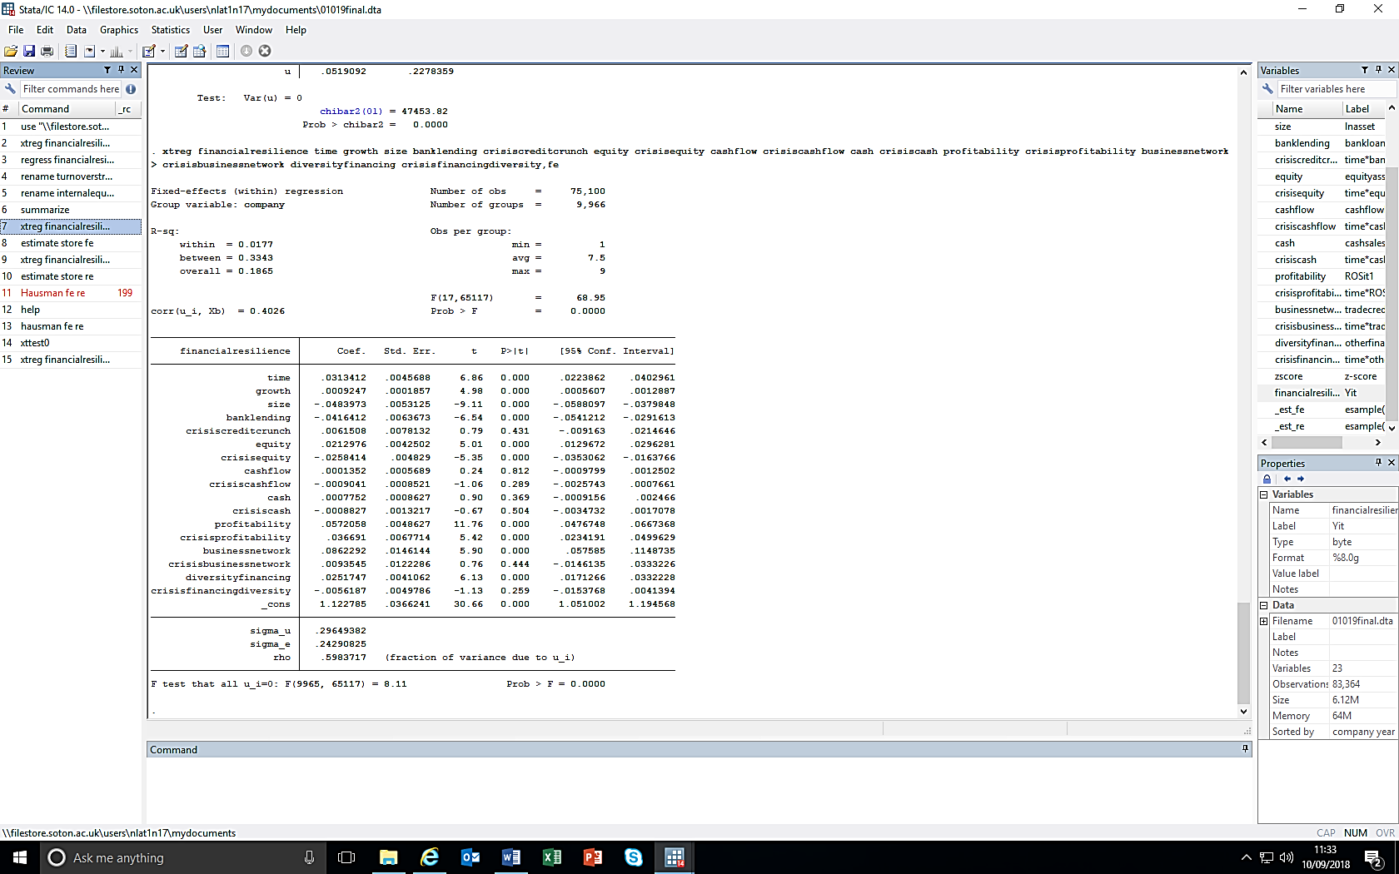

# Appendix IV. Correlation matrix